Name _______________________________________________ Date ______________ Period _________
Star Wars: A New Hope: Film Study
1. In this movie, sound plays an important role in the mood and telling of the story, list 5 different scenes in which the sound played an important role:
Describe the Scene | Describe the Sound | Impact of the Sound on the Scene
1.
2.
3.
4.
5.
2. What sound had the largest impact on the movie in your opinion, why?
3. How does the soundtrack (not just the music) enhance the film? Why?
4. The Star Wars films were dramatically ahead of its time, but do they over 30 years later still hold up as a film? Why or why not?
5. In your opinion what is the overall moral or lesson of the film?
6. Note the special effects used in the film, how to they impact the overall
7. List 5 iconic things that demonstrate symbolism of the struggle of good versus evil in the film:
Good or Evil? | Thing from the film | How does this demonstrate the symbolism?
1.
2.
3.
4.
5.

Star Wars: A New Hope: Types of Sound
Diegetic Sound | Non-Diegetic Sound
refers to all those audio elements that we see inside the film frame, including dialogue, doors slamming, footsteps, etc. | refers to all those audio elements that come from off-screen, including the musical score and sound effects like the ticking of a clock, etc.
Why distinguish between diegetic and non-diegetic sound?
The most important reason for distinguishing diegetic from non-diegetic sound is to draw attention to the way sound effects are used in movies. For the most part, audiences don’t notice the sounds that come from inside the film frame. We may pay attention to a particular song or the sound of a scream from off in the distance. But when we hear characters speak, slam doors, or travel in cars, we rarely notice how crucial each of these sounds is to the overall success of the movie. It’s only when the synchronization between an action and a sound effect is broken that we notice the role of the sound effects. Think, for instance, of any foreign language movie you’ve seen that has been dubbed into English. Dubbed films are disappointing because the actors’ lips don’t synchronize with the dialogue, leaving the film feeling hollow and unsatisfying. By noting the different ways diegetic and non-diegetic sounds are used, the point is to become aware of how these sounds help to shape a film.

Directions: Use the chart below to assess the role of diegetic and non-diegetic sound. Determine the major themes in the movie you have watched. Then choose five examples each of diegetic and non-diegetic sound effects from both the opening and closing 5 minutes of the film. When you are selecting your examples, choose sound effects that have some relationship to the main themes in the film. List your examples in the left hand column of the chart. In the right hand column, suggest how the selected sound relates to or helps to draw out the film’s main themes.
Example of Diegetic Sound | Relationship of Diegetic Sound to the Film’s Main theme

Example of Non-Diegetic Sound | Relationship of Non-Diegetic Sound to the Film’s Main theme

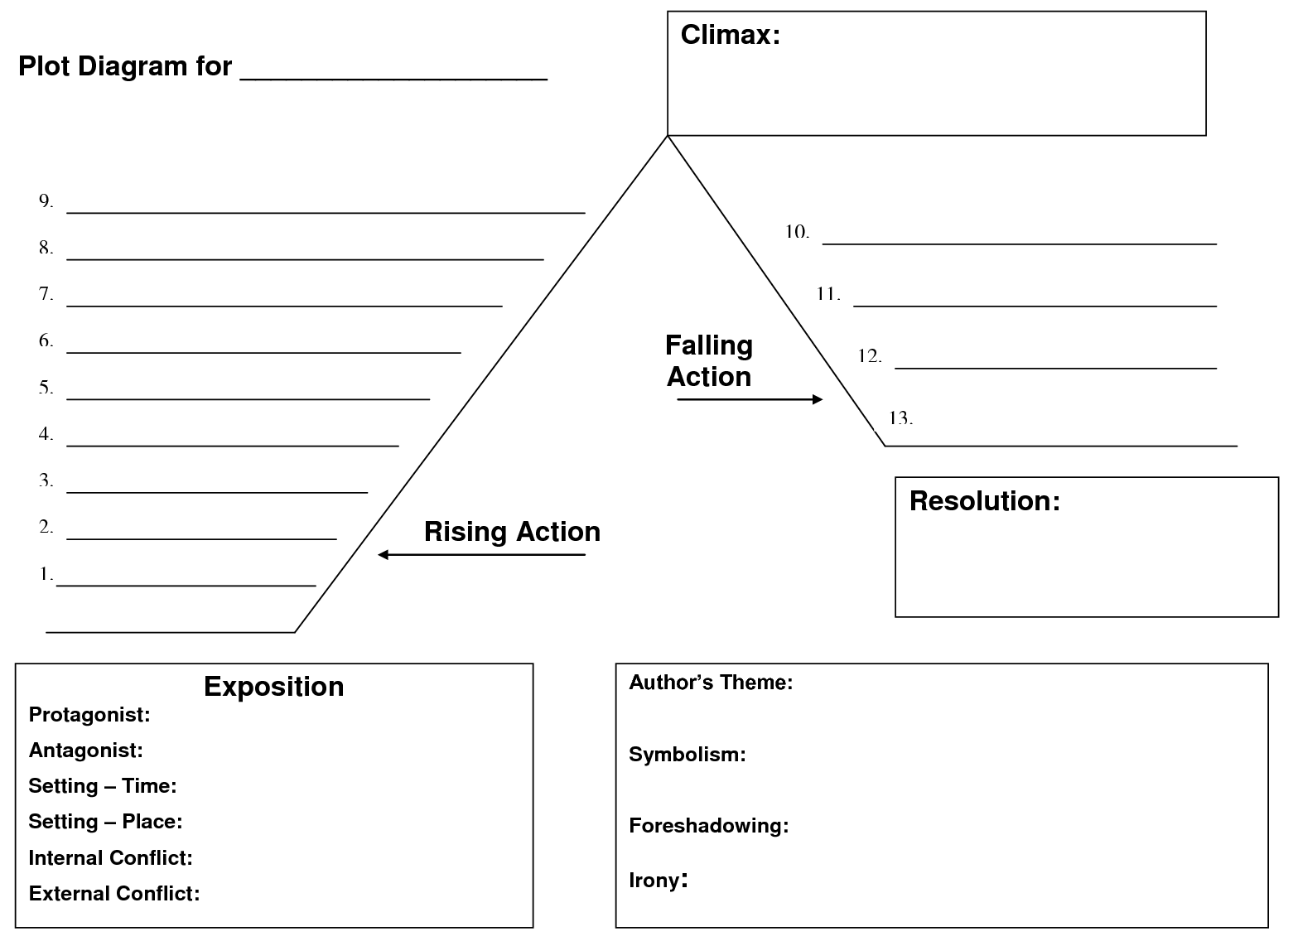
Name ______________________________________ Date ___________

Star Wars: A New Hope: Plot Diagram

